**Course: Advanced Bioinformatics**

**Module title: ML Concepts**

**Module no. : 186**

**ML Concepts**

Association Analysis

Supervised Learning

* Classification

* Regression/Prediction

Unsupervised Learning

Reinforcement Learning

**Learning Associations**

Basket analysis:

P (Y | X ) probability that somebody who buys X also buys Y where X and Y are products/services.

Example: P ( chips | Beer) = 0.7

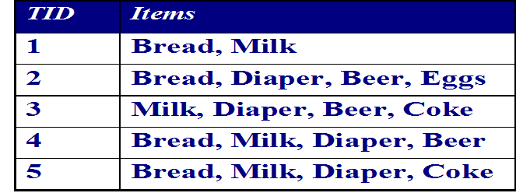

**Classification**

* Example: Credit scoring
* Differentiating between low-risk and high-risk customers from their income and savings

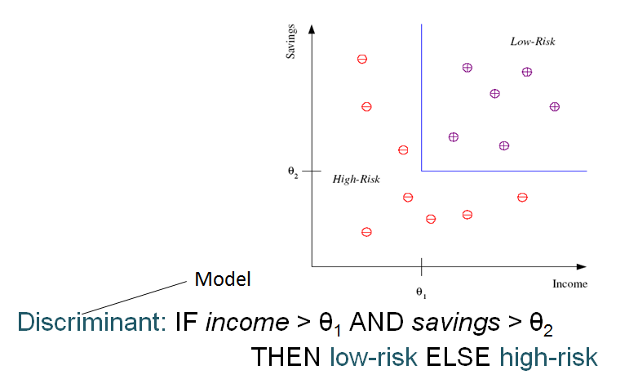

**Classification Apps**

FR: Pose,lighting,occlusion(glasses,beard), make-up, hair style

Character recognition:

Speech recognition:

Medical diagnosis: From symptoms to illnesses

Web Advertising

**Prediction: Regression**

* Example: Price of a used car
* *x* : car attributes

*y* : price

*y* = *g* (*x* | *θ* )

*g* ( ) model,

*θ* parameters

